|  |
| --- |
| Getting Started with the NI CompactRIO Control and Mechatronics Bundle |
| National Instruments |



|  |
| --- |
|  |

Table of Contents

1. Overview of the NI CompactRIO Control and Mechatronics Bundle 3

1.1 CompactRIO Real-Time Controller 3

1.2 Reconfigurable Chassis with FPGA 3

1.3 I/O Modules 3

2. Installing the Appropriate Software 4

3. Connecting to Your Hardware 8

4. Exploring a LabVIEW Project 19

5. Using the NI CompactRIO Control and Mechatronics Bundle FPGA Personality 21

6. Leveraging the Pre-Built Templates 24

PI Control (MathScript) Simulation.vi 26

PID Control (CD&Sim) Simulation.vi 26

Pole Placement Control Simulation.vi 27

Implementation Templates 27

PI Control (MathScript) cRIO.vi 28

PI Control (CD&Sim) cRIO.vi 29

7. Resources 30

8. Applications 30

High-Speed/High-Precision Control 30

Multi-Domain Modeling 30

Hardware in the Loop (HIL) 31

Robotics 31

Rapid Control Prototyping 31

Process Control 31

Green Energy 31

Advanced Manufacturing 31

9. References 31

# 1. Overview of the NI CompactRIO Control and Mechatronics Bundle

The National Instruments CompactRIO Control and Mechatronics Bundle is an embedded control platform that consists of four major components: real-time controller, reconfigurable chassis with FPGA, and I/O modules. The CompactRIO bundle delivers loop rates up to 40 Mhz and deterministic execution of control algorithms for various control and mechatronics applications. You can use the Control and Mechatronics Bundle with LabVIEW to create functionality that you define using both graphical and textual programming.

Using this Getting Started Guide, you can leverage a pre-built FPGA personality and templates that enable students to connect the theory learned in the classroom with the real world. This document explains how to leverage the FPGA personality and templates and get up and running quickly with your new CompactRIO system.

## 1.1 CompactRIO Real-Time Controller

The CompactRIO real-time controller (NI cRIO-9024) has an 800 MHz industrial processor that balances low power consumption and powerful real-time control algorithms, signal analysis, and data logging. CompactRIO real-time controllers enable you to directly deploy your control algorithm and run the code untethered on the real-time processor without a code generation step for the user [1].

## 1.2 Reconfigurable Chassis with FPGA

Field-programmable gate arrays (FPGAs) are reprogrammable silicon chips. In contrast to processors in PCs, programming an FPGA rewires the chip itself to implement your functionality rather than running a software application. Ross Freeman, the cofounder of Xilinx, invented the first FPGA in 1985. NI has partnered with Xilinx to offer their cutting-edge FPGA technology in a variety of hardware platforms [2].

With the NI CompactRIO Control and Mechatronics Bundle, you can program the FPGA yourself or use the FPGA personality provided.

## 1.3 I/O Modules

NI C Series I/O modules are self-contained measurement modules. All circuitry required for measurement is contained in the module itself. All A/D and D/A conversion occur in the module before the data reaches the chassis.   
  
Each I/O module contains built-in signal conditioning and screw terminal, BNC, or D-Sub connectors. A variety of I/O types is available, including ±80 mV thermocouple inputs, ±10 V simultaneous-sampling analog inputs/outputs, 24 V industrial digital I/O with up to 1 A current drive, differential/TTL digital inputs with 5 V regulated supply output for encoders, and 250 Vrms universal digital inputs [3].

The NI CompactRIO Control and Mechatronics Bundle includes three general-purpose C Series modules that should cover most control and mechatronics experiments. The modules are an analog input module, an analog output module, and a bidirectional digital module.

# 2. Installing the Appropriate Software

CompactRIO is programmed using NI LabVIEW, a comprehensive development environment that provides engineers and scientists unprecedented hardware integration and wide-ranging compatibility [4]. Because CompactRIO is a distributed real-time system, it also uses the LabVIEW Real-Time Module and, optionally, the LabVIEW FPGA Module*. CompactRIO also requires the NI-RIO driver to be installed on your development PC to support real-time controllers, reconfigurable chassis, and C Series modules.

The templates and FPGA personality provided in the NI CompactRIO Control and Mechatronics Bundle are built on the 2011 version of National Instruments Software. The following is the required software for using the templates provided with the NI Control and Mechatronics CompactRIO Bundle:

* [LabVIEW Development System](http://www.ni.com/labview/)
* [LabVIEW Real-Time Module](http://sine.ni.com/nips/cds/view/p/lang/en/nid/209855)
* [LabVIEW FPGA Module](http://www.ni.com/fpga/)
* [LabVIEW Control Design & Simulation Module (CD&Sim)](http://www.ni.com/labview/cd-sim/)
* [LabVIEW MatchScript RT Module](http://sine.ni.com/nips/cds/view/p/lang/en/nid/207300)
* [NI-RIO driver](http://search.ni.com/nisearch/app/main/p/bot/no/ap/tech/lang/en/pg/1/sn/catnav:du/q/rio/)

Although you can install each of these software components separately, the easiest way to install them is using the LabVIEW Platform DVD. If you are not using the LabVIEW Platform DVD, it is important to install the software in the order listed above.

**Installing Software with the LabVIEW Platform DVD**

1. Insert the DVD in the DVD drive of your development PC and wait for the autorun screen to appear. Then select **Install LabVIEW, Modules, and Toolkits**. If you receive a Windows warning asking if you want to continue, click Yes.
2. Select whether you want to enter serial numbers for the software products you have purchased or install them in evaluation mode. If you choose to enter serial numbers, the installer can select the appropriate software to install for you. If you choose to install in evaluation mode, proceed to Step 5.

*The NI-cRIO 9024 controller supports a feature called Scan Interface mode. Scan Interface mode enables you to access I/O from the cRIO system without programming the FPGA. You still need to install LabVIEW FPGA to use the provided FPGA personality and templates.

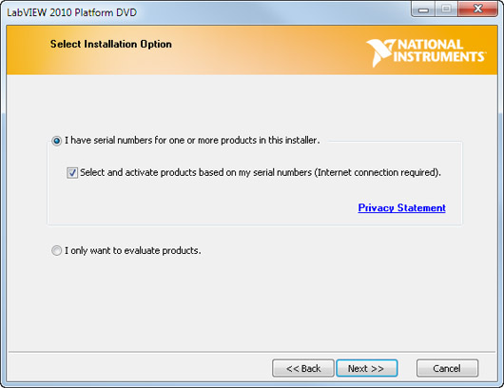

Figure . LabVIEW Installation Option

1. Enter serial numbers for the LabVIEW development system you have purchased. If you have serial numbers for LabVIEW add-ons, such as modules and toolkits like CD&Sim and MathScript, you can also enter those serial numbers now.

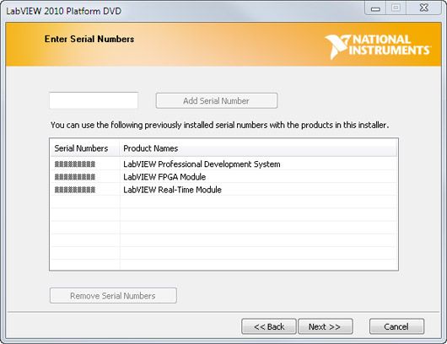

Figure . LabVIEW Installation Activation

1. Review the Licensed Product List, which includes the LabVIEW environment, modules, and toolkits you have valid licenses for in addition to device drivers. Then click **Next**.

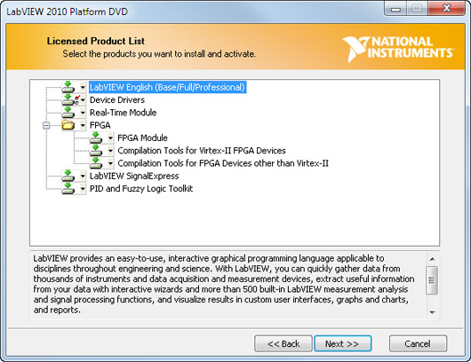

Figure . LabVIEW Installation Licensed Product List

1. Select additional products to install for evaluation from the Evaluation Product List.

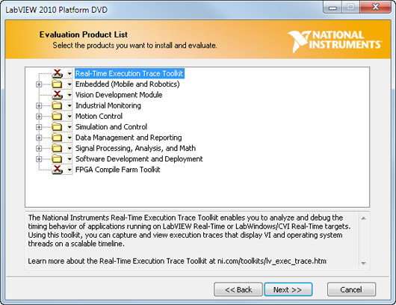

Figure . LabVIEW Installation Additional Products

1. The installer checks for patches and updates for the products you are about to install. You can download the updates before continuing with the installation.
2. Choose the installation directory for National Instruments software.
3. Accept the License Agreement(s) and then click **Next**.
4. Enter your full name and organization. This information will be used to complete your software registration.
5. Review the summary before continuing to ensure all your products will be installed. Products listed with (User interaction required) require user interaction to complete. Otherwise, the installation may be left unattended.

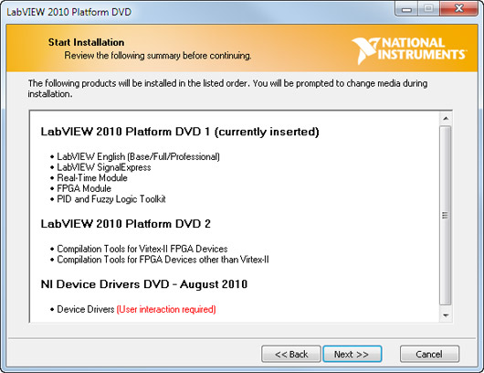

Figure . LabVIEW Installation Summary

1. Insert the Device Drivers DVD when prompted, and make the following selections from the selection tree:
   * Deselect **Data Acquisition** and dependent features unless you plan to use an NI data acquisition (DAQ) device.
   * Accept the license agreement. When the installer finishes you will have all of the necessary software installed on your development PC to create CompactRIO applications.

# 3. Connecting to Your Hardware

A CompactRIO system consists of four main components: a real-time controller, a reconfigurable FPGA-based chassis, C Series I/O modules, and software. Your first step in setting up your CompactRIO system was installing the software on your development PC. In this section, you set up the hardware and connect it to your network.

**Connecting the Chassis and Controller**

1. Complete the following steps to connect the chassis and controller. Ensure that there is no power connected to the controller.
2. Align the controller and the chassis as shown in Figure 6.
3. Slide the controller onto the chassis connector. Press firmly to ensure the chassis connector and controller connector are mated.
4. Using a number 2 Phillips screwdriver, tighten the two captive screws on the front of the controller to 1.3 N · m (11.5 lb · in) of torque.

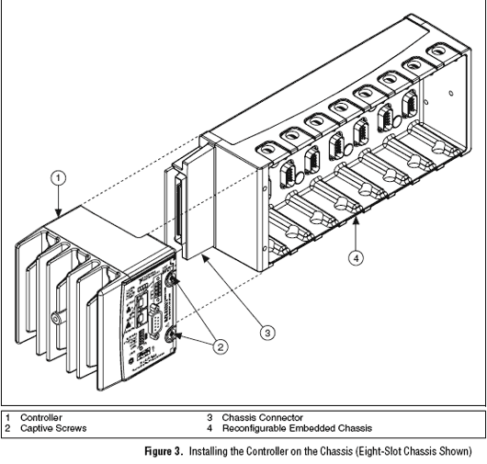

Figure 6. Connecting CompactRIO Chassis and Controller

**Installing C Series Modules**

Complete the following steps to install a C Series I/O module in the chassis:

1. Make sure that no I/O-side power is connected to the module. Because C Series modules are hot swappable, if the system is in a nonhazardous location, the chassis power can be on when you install modules.
2. Align the C Series module with a module slot in the chassis as shown above. The module slots are labeled 1 to 8, left to right.

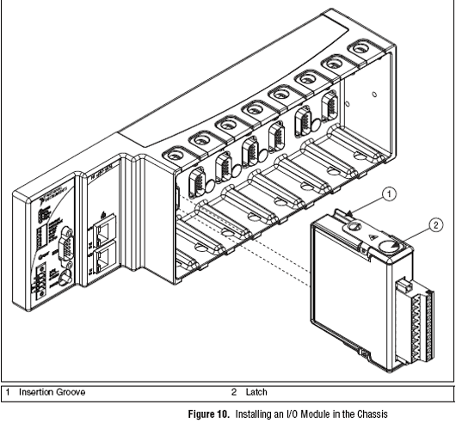

Figure . Inserting I/O Modules

1. Squeeze the latches and insert the module into the module slot.
2. Press firmly on the connector side of the C Series module until the latches lock the module into place.
3. Repeat these steps to install additional I/O modules.

**Connecting Ethernet and Power**

CompactRIO systems use Ethernet for almost all configuration and other communication with the development or host PC. To connect to an Ethernet network (hub or router), use a standard Category (CAT-5) or better shielded, twisted-pair Ethernet cable, or use an Ethernet crossover cable to connect the chassis directly to your computer.

Before connecting power, ensure that all controller DIP switches are in the OFF position. All DIP switches are in the OFF position when the chassis is shipped from National Instruments.

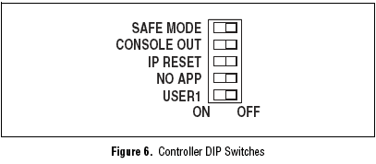

Figure . CompactRIO Default Dip Switches Position

The controller has one layer of reverse-voltage protection. Complete the following steps to connect a power supply to the controller:

1. Ensure the power supply is not energized (not plugged into a power source) before connecting any wires.
2. Remove the COMBICON power connector from the front panel of the controller by loosening the two captive screws that hold it in place.
3. Connect the positive lead of the power supply to the V1 or V2 terminal and the negative lead to one of the C terminals on the COMBICON power connector. Tighten the leads in the connector by turning the captive screws on the side of the connector and ensure the wires are snugly in place.
4. Re-attach the COMBICON connector to the front panel of the controller.

**Configure the NI CompactRIO System for First Use**

Complete the following steps to configure the system:

1. Ensure that all controller DIP switches are in the OFF position.

If you made any changes to the DIP switch positions, reset by pressing the RESET button on the controller for the settings to take effect.

1. Disable secondary network interfaces, such as the wireless access card on a laptop.

*During initial setup, National Instruments software searches for your CompactRIO system through the primary network interface on your computer. Disabling all additional network interfaces ensures that your CompactRIO system is easy to find on the network.*

1. Open Measurement & Automation Explorer (MAX) from the Windows Start menu at **All Programs»National Instruments»Measurement & Automation**.
   1. Expand *Remote Systems*

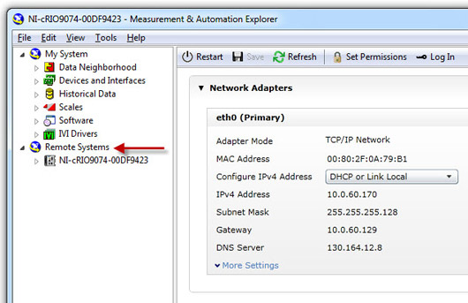

* 1. You should see your CompactRIO system under Remote Systems*.* Select it to view the network settings and then choose the appropriate option below.
     + [I do not see my CompactRIO system under Remote Systems](http://www.ni.com/gettingstarted/setuphardware/compactrio/troubleshootmax.htm)
     + [I see my controller with an automatically assigned IP address (not 0.0.0.0)](http://www.ni.com/gettingstarted/setuphardware/compactrio/controllersoftware.htm)

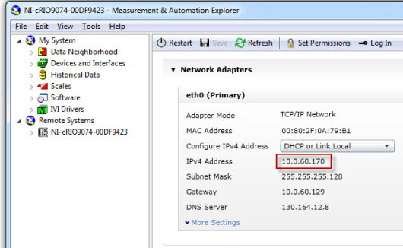

* + - [I see an IP address of 0.0.0.0 and my CompactRIO system is connected to a network that automatically assigns IP addresses (has a DHCP server)](http://www.ni.com/gettingstarted/setuphardware/compactrio/dhcp.htm)

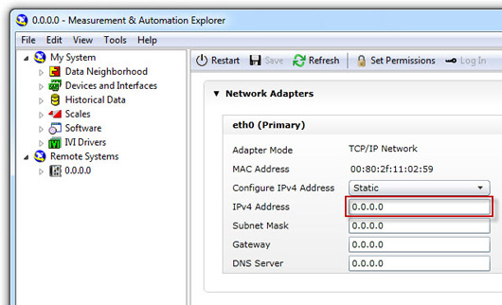

* + - [I see an IP address of 0.0.0.0 and my CompactRIO system is connected directly to my computer with a crossover cable or to a switch without a DHCP server](http://www.ni.com/gettingstarted/setuphardware/compactrio/staticip.htm)



**Install Software on Your NI CompactRIO Controller**

At this point, your NI CompactRIO controller should be configured with a valid IP address and the correct software should be installed on your development computer. The status light on your CompactRIO controller should be repeatedly blinking twice. This indicates that a valid IP address is assigned, but there is no software installed on the controller.

1. You may provide a name for your CompactRIO controller that will identify it on the network and also a comment that is visible to other users. Enter these now if you wish; both are optional. Select the “System Settings” tab at the bottom to enter the name and comment. Click **Save**.

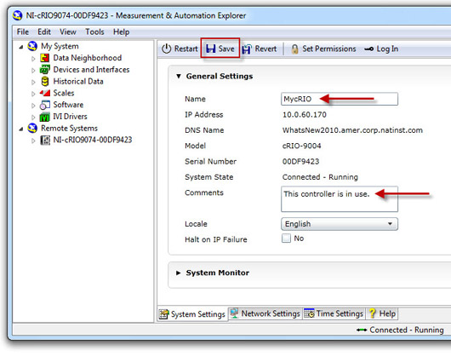

1. Expand the CompactRIO item under Remote Systems, right-click on the Software item, and select **Add/Remove Software.**

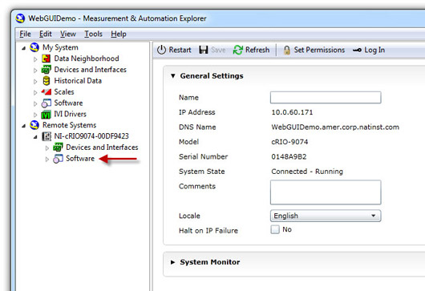

1. Under the desired LabVIEW Real-Time version, select the NI-RIO item that includes **NI Scan Engine support**.

This package installs the typical components required. If you have additional LabVIEW modules or toolkits installed, such as vision or motion, and would like to install them on your CompactRIO system, select ***“Custom software installation.” “ Custom software installation” will be needed to use the included templates.***

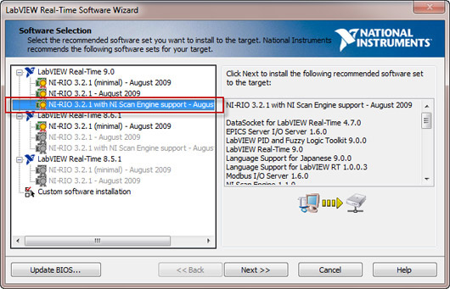

1. Click **Next.** If you selected “Custom software installation” above, click Yes to the warning. You will also need to select each item that you would like to install from the list. If you are unsure, simply choose to install all listed items. To use the included templates, the LabVIEW Control Design & Simulation Module will need to be installed.
2. Click **Next** to begin the software installation. If you receive an error during installation, repeat this process. If you repeatedly receive errors while attempting to install, ensure that you have properly completed the network configuration process.
3. Click **Finish** to complete the process.

**Adding the CompactRIO System to a LabVIEW Project**

You must add the CompactRIO system to a LabVIEW project so that you can program it.This section shows you how to use the CompactRIO system with the provided NI Control Bundle Project.lvproj or, alternatively, how to create your own project.

**Editing LabVIEW Control Bundle Project.lvproj to Use Your CompactRIO System**

The project included in the NI Control and Mechatronics cRIO Bundle already contains a CompactRIO target. To ensure that this target is pointed to your hardware, follow these steps:

1. Right-click the controller in the project and select **Properties**.

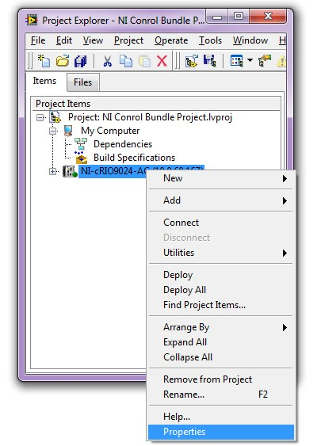

Figure . CompactRIO Properties

1. Here you can change the IP address of the cRIO in the project to match the IP address of your CompactRIO system as seen in MAX.

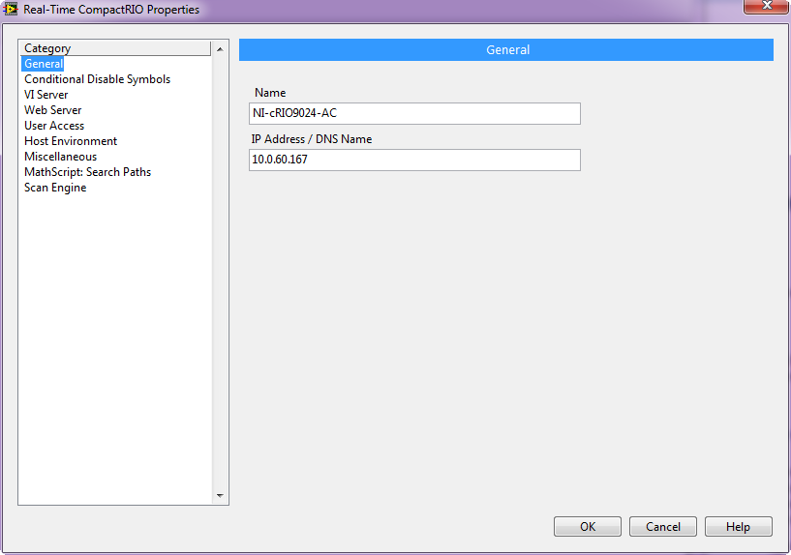

Figure . Configure CompactRIO IP Address

**Adding a CompactRIO System to a New Project**

Use the following steps to learn how to add the CompactRIO system to a new project of your own:

1. Open a blank LabVIEW project.
2. Right-click the project name and select **New>>Targets and Devices…**
3. On the Add Targets and Devices... dialog box that appears, find the cRIO-9024 under Real-Time CompactRIO and click **OK**.

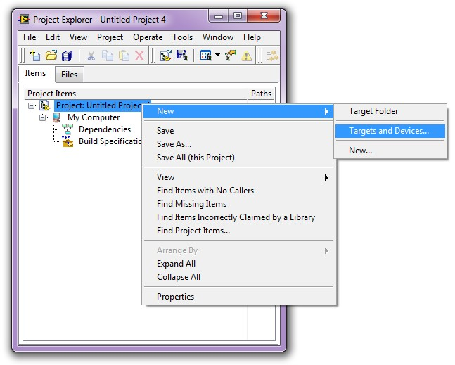

Figure . Add New Targets and Devices in Project

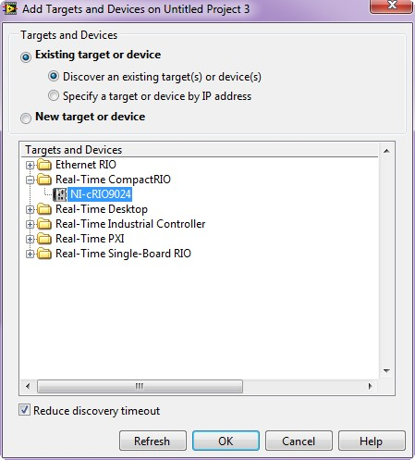

Figure . Select Existing CompactRIO Target

1. Choose the option to use the LabVIEW FPGA Interface programming mode.

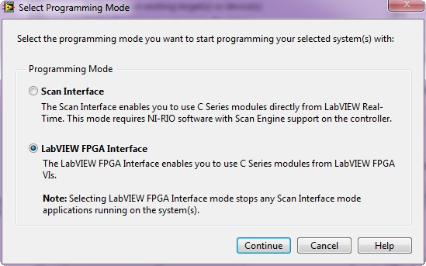

Figure . Programming Mode Selection

1. LabVIEW adds the controller, chassis, and modules to your project.

# 4. Exploring a LabVIEW Project

Included are several VI templates that leverage the FPGA personality written for the NI CompactRIO Control and Mechatronics Bundle. Before using these templates, you should learn a little about the structure of a LabVIEW Project.

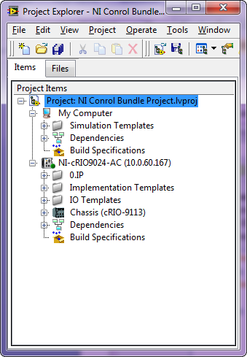

Figure . NI Control Bundle Project

A LabVIEW project is organized in a hierarchical fashion. In the NI Control Bundle Project, there are two processing units. One is called *My Computer* and is the Windows-based PC where development takes place and where simulation code can be run. This processing unit is often called the “*host*”. The other processing unit is the CompactRIO system. Any processors other than the host that appear in the project are commonly referred to as “*targets*” because a typical design flow is to develop code on the host and then deploy it to a target where real inputs and outputs can be used. Simulations can also run on the real-time processor of a target without connecting to I/O. The code provided in the bundle use the host processing unit for simulations and the target processing unit (CompactRIO) for connecting the code we validate in simulation to real I/O. It is important to note that simulation code can run on either processing unit but development can take place only on the host. You can see that both processing units (the host and the target) are at the same level in the hierarchy. The items under My Computer are specific to that processor and will run only on the host PC. The items under the CompactRIO system are specific to that processor and will run only on that target. It is possible to have multiple targets in one project.

# 5. Using the NI CompactRIO Control and Mechatronics Bundle FPGA Personality

Unless you are using Scan Interface programming mode, you must program the FPGA to access the I/O of a CompactRIO system. In order to help you get up and running more quickly, we have provided an FPGA personality that you can use to access the I/O of the three modules included in the bundle. This means that you will not have to program the FPGA yourself in order to use the CompactRIO system. When an FPGA personality is created and compiled, it is specific to the slot order of the modules in the chassis at the time it was created. Therefore, to use the FPGA personality provided, you need the following chassis configuration:

Slot 1: NI 9201  
Slot 2: NI 9263  
Slot 3: NI 9401

To explore the functionality of the FPGA personality, open the Control Bundle FPGA VI located in the project tree as shown in Figure 16.

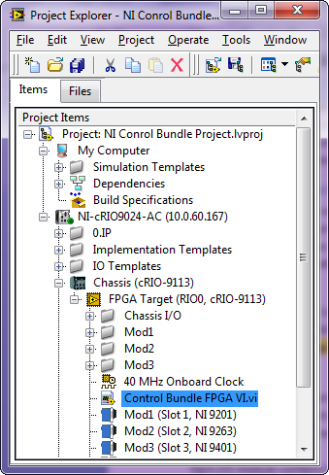

Figure . Control Bundle FPGA VI

This VI contains the code that runs on the FPGA and has already been compiled to a bitfile* called Control Bundle FPGA Bitfile.lvbitx, located under the FPGA target in the project. The code that runs on the FPGA is called an FPGA personality because it dictates the behavior of the FPGA. Control Bundle FPGA VI.vi contains six loops. Each loop corresponds to I/O that you may want to use in your application. The I/O programmed for you in the Control Bundle FPGA VI.vi contains the following:

*An FPGA VI must be compiled in order to run on the target. When an FPGA VI is compiled, a bitfile is created that contains all of the functionality of the VI in a compiled format.

* Analog input
* Analog output
* Quadrature encoder input (corresponding to lines 0-3 of the NI 9401)
* PWM generation (corresponding to lines 4-7 of the NI 9401)
* Digital input (uses lines 0-3 of the NI 9401)
* Digital Output (Optional use of lines 4-7 of the NI 9401)

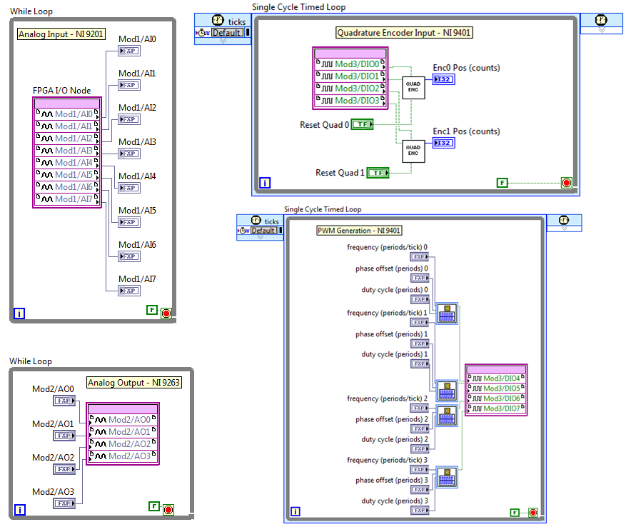

Figure . FPGA Personality of Analog Input (top left), Analog Output (bottom left), Quadrature Encoder Input (top right), and PWM Generation (bottom right)

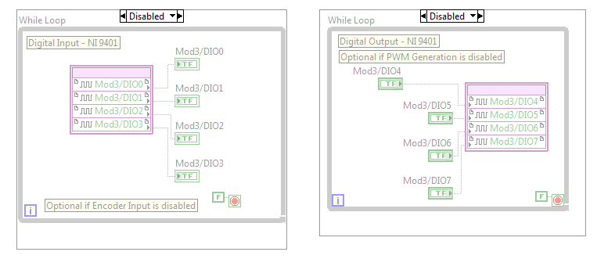

Figure . Optional FPGA I/O

Optional I/O:

If you want to access straight digital I/O instead of using the digital module for quadrature encoder input and/or PWM output, you can enable the Digital Input and/or Digital Output loops of the FPGA personality. To enable these loops, right-click on the border of the Diagram Disable Structure around each loop and select **Remove Diagram Disable Structure**. Then place a Diagram Disable Structure around the Quadrature Encoder Input Loop if you want to use straight digital input and/or around the PWM Generation Loop if you want to use straight digital output, because these loops access the same digital I/O lines of the NI 9401.

Alternatively, if you want to customize the functionality of the FPGA instead of using the provided FPGA personality, you can program the FPGA yourself by referring to the [LabVIEW FPGA Module Training](http://zone.ni.com/devzone/cda/tut/p/id/3555).

# 6. Using the Pre-Built Templates

The VIs in the Simulation Templates folder of the project, shown in Figure 19, run on the host PC because they are located under My Computer in the project hierarchy. These VIs contain code that is not connected to I/O and is meant to be used to validate algorithms in simulation before being connected to physical inputs and outputs.

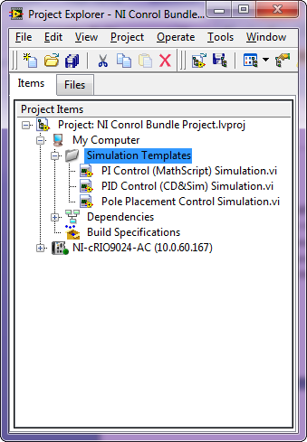

Figure . NI Control Bundle Simulation Templates

### PI Control (MathScript) Simulation.vi

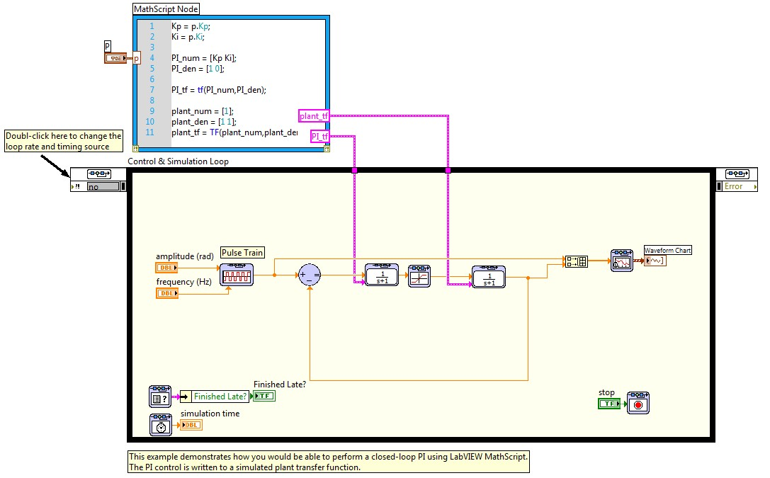

This VI shows a PI control algorithm implemented using a combination of graphical (LabVIEW Control Design & Simulation Module) and textual (LabVIEW MathScript RT) tools. MathScript enables you to use existing m-scripts or to create new code in a textual format.

### PID Control (CD&Sim) Simulation.vi

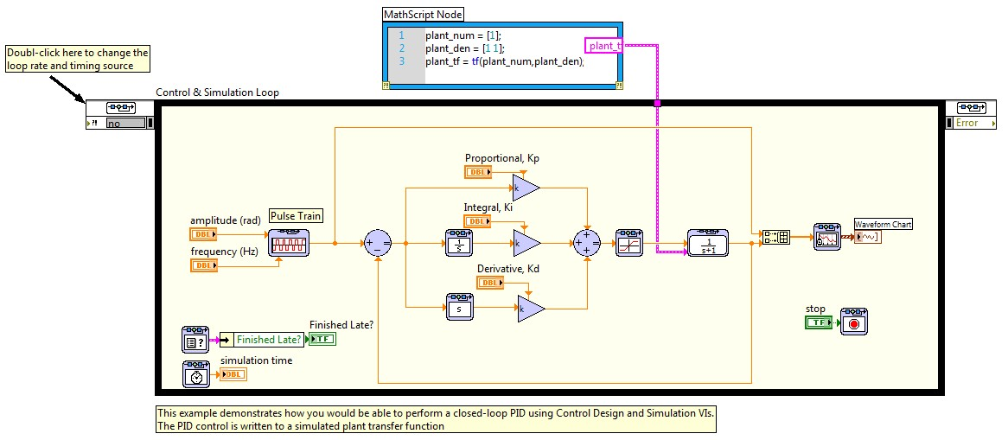

This VI shows PID implemented graphically using the LabVIEW Control Design & Simulation Module. This approach enables students to visualize PID in code just as they would in a textbook. This VI uses MathScript to model the plant.

### Pole Placement Control Simulation.vi

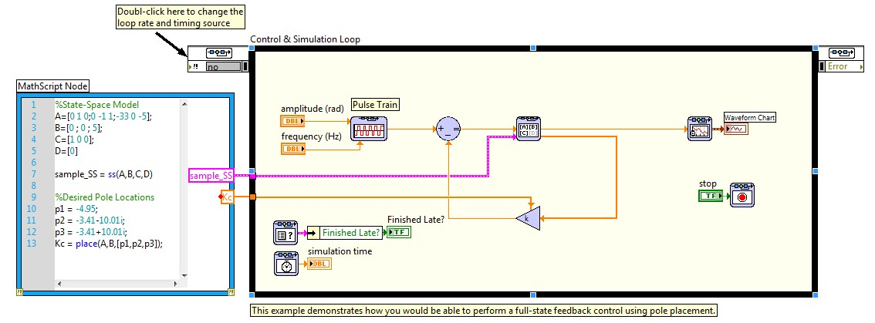

This VI combines graphical (LabVIEW Control Design & Simulation Module) and textual (LabVIEW MathScript RT) approaches to implement Pole Placement design for full-state feedback control. Students can choose whether to implement their designs graphically or textually or to use a hybrid approach.

## Implementation Templates

The VIs in the Implementation Templates folder of the project, shown in Figure 20, run on the real-time processor of the target because they are located under the CompactRIO system in the project hierarchy. These VIs contain code that is connected to I/O by the FPGA personality referenced in each VI.

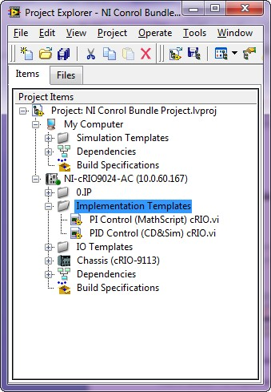

Figure . NI Control Bundle Implementation Templates

### PI Control (MathScript) cRIO.vi

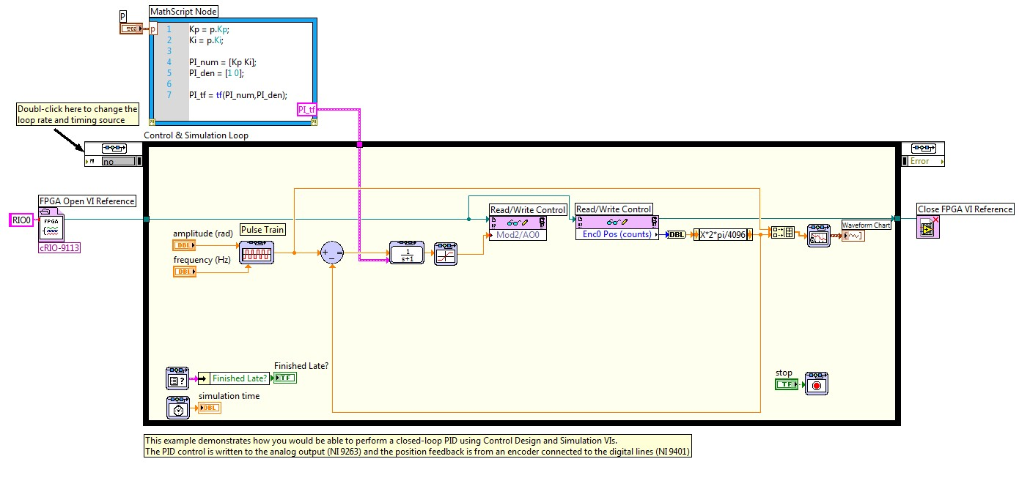

This VI shows a PI control algorithm implemented using a combination of graphical (LabVIEW Control Design & Simulation Module) and textual (LabVIEW MathScript RT) tools. This VI is very similar to PI Control (MathScript) Simulation.vi, discussed in the Simulation section; however, in this version, the simulated plant has been replaced with real I/O nodes. As discussed earlier, the inputs and outputs of each module are accessed through the FPGA. In order to run code on hardware, you must reference the code that dictates the behavior of the FPGA. In this case, we have written that code for you as discussed in 4. Exploring a LabVIEW Project. The FPGA personality is referenced in the PI Control (MathScript) cRIO.vi through the FPGA Open Reference.vi on the block diagram. By double-clicking this VI, you can see that it points to the bitfile created when the Control Bundle FPGA.vi was compiled.

### PID Control (CD&Sim) cRIO.vi

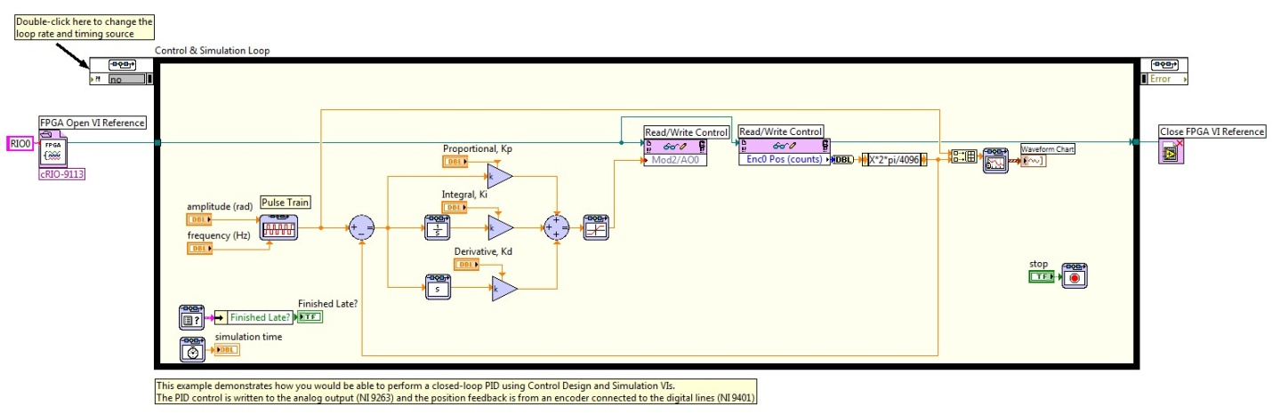

This VI shows PID implemented graphically using the LabVIEW Control Design & Simulation Module. This approach enables students to visualize PID in code just as they would in a textbook. This VI is very similar to PID Control (CD&Sim) Simulation.vi discussed in the Simulation section; however, in this version, the simulated plant has been replaced with real I/O.

Note: Both PI Control (MathScript) cRIO.vi and PID Control (CD&Sim) cRIO.vi convert the ticks of the encoder to radians, assuming 4096 ticks per revolution for the encoder. Your particular encoder may be different and therefore it may be necessary to change this constant for your particular hardware.

# 7. Resources

* [Video Instruction for Students](http://www.ni.com/academic/students/learnlabview/)[Introduction to LabVIEW in 3 Hours for Control Design and Simulation](http://zone.ni.com/devzone/cda/tut/p/id/5855)
* [What is the NI LabVIEW MathScript RT Module?](http://zone.ni.com/devzone/cda/tut/p/id/6206)
* [Teaching Controls and Mechatronics](http://www.ni.com/academic/controls)
* [NI-cRIO 9024 Specifications](http://sine.ni.com/nips/cds/nisearchservlet?nistype=psrelcon&nid=207371&lang=en&q=FQL:%28%28nilangs:en%29%29%20AND%20%28%28phwebnt:12223%29%29%20%20AND%20%28nicontenttype:productmanual%29%20AND%20%28docstatus:current%29%20AND%20%28doctype:specifications%29)
* [NI-cRIO 9113 Specifications](http://sine.ni.com/nips/cds/nisearchservlet?nistype=psrelcon&nid=206764&lang=en&q=FQL:%28%28nilangs:en%29%29%20AND%20%28%28phwebnt:10944%29%29%20%20AND%20%28nicontenttype:productmanual%29%20AND%20%28docstatus:current%29%20AND%20%28doctype:specifications%29)
* [NI 9201 Specifications](http://sine.ni.com/nips/cds/nisearchservlet?nistype=psrelcon&nid=208798&lang=en&q=FQL:%28%28nilangs:en%29%29%20AND%20%28%28phwebnt:4886%29%29%20%20AND%20%28nicontenttype:productmanual%29%20AND%20%28docstatus:current%29%20AND%20%28doctype:specifications%29R)
* [NI 9263 Specifications](http://sine.ni.com/nips/cds/nisearchservlet?nistype=psrelcon&nid=208806&lang=en&q=FQL:%28%28nilangs:en%29%29%20AND%20%28%28phwebnt:4892%29%29%20%20AND%20%28nicontenttype:productmanual%29%20AND%20%28docstatus:current%29%20AND%20%28doctype:specifications%29R)
* [NI 9401 Specifications](http://sine.ni.com/nips/cds/nisearchservlet?nistype=psrelcon&nid=208809&lang=en&q=FQL:%28%28nilangs:en%29%29%20AND%20%28%28phwebnt:6757%29%29%20%20AND%20%28nicontenttype:productmanual%29%20AND%20%28docstatus:current%29%20AND%20%28doctype:specifications%29R)

**Pin Assignments**

Figure . Pin Assignments for NI 9201 (Left) NI 9263 (Middle) NI 9401 (Right)

# 8. Applications

### High Speed/High Precision Control

[Real-time control of ECP Rectilinear Plant at the University of Texas](http://zone.ni.com/devzone/cda/tut/p/id/6784)

### Multi-Domain Modeling

[Introduction to Digital and Analog Co-simulation Between NI LabVIEW and NI Multisim](http://zone.ni.com/devzone/cda/tut/p/id/13663)

### Hardware in the Loop (HIL)

[Siemens Wind Power Develops a Hardware-in-the-Loop Simulator for Wind Turbine Control System Software Testing](http://sine.ni.com/cs/app/doc/p/id/cs-12344)

### Robotics

[UC San Diego Uses LabVIEW and NI Single-Board RIO to Build an Agile Mobile Robot](http://sine.ni.com/cs/app/doc/p/id/cs-14234)

[University of Florida Students Use LabVIEW and CompactRIO to Design and Implement Dynamic Radiographic Imaging Control Software on a Mitsubishi Robotic Manipulator](http://sine.ni.com/cs/app/doc/p/id/cs-14155)

### Rapid Control Prototyping

[MIT Students Use LabVIEW and CompactRIO to Design and Implement a Dynamic Output Feedback Controller](http://sine.ni.com/cs/app/doc/p/id/cs-13446)

### Process Control

[Multivariable Model Predictive Control for Coax-Manufacturing Processes](http://sine.ni.com/cs/app/doc/p/id/cs-11491)

### Green Energy

[Using NI CompactRIO to Design a Maximum Power Point Tracking Controller for Solar Energy Applications](http://sine.ni.com/cs/app/doc/p/id/cs-11738)

### Advanced Manufacturing

[M.I.T. Works with National Instruments Design Software and Hardware](http://zone.ni.com/devzone/cda/tut/p/id/13158#toc0)

# 9. References

[1] [NIcRIO-9024](http://sine.ni.com/nips/cds/view/p/lang/en/nid/207371)

[2] [NI FPGA](http://www.ni.com/fpga/)

[3] [NI C Series I/O Modules](http://sine.ni.com/nips/cds/view/p/lang/en/nid/206532)

[4][LabVIEW System Design Software](http://www.ni.com/labview/)